**CREATE EMPLOYEE TABLE**

create table employee(

emp_id int AUTO_INCREMENT,

first_name varchar(255),

last_name varchar(255),

Salary int,

Joining_dt date,

Department varchar (255),

constraint PK_employee_emp_id Primary KEY (emp_id)

);

**CREATE INCENTIVE TABLE**

create table incentives(

inc_id int AUTO_INCREMENT,

emp_ref_id int,

incentive_dt date,

incentive_amt int,

CONSTRAINT PK_incentive_inc_id PRIMARY KEY (inc_id),

CONSTRAINT FK_incentives_emp_ref_id FOREIGN KEY(emp_ref_id) REFERENCES employee(emp_id)

);

**QUERIES ANS:-**

**a).** SELECT FIRST_NAME AS FirstName FROM employee;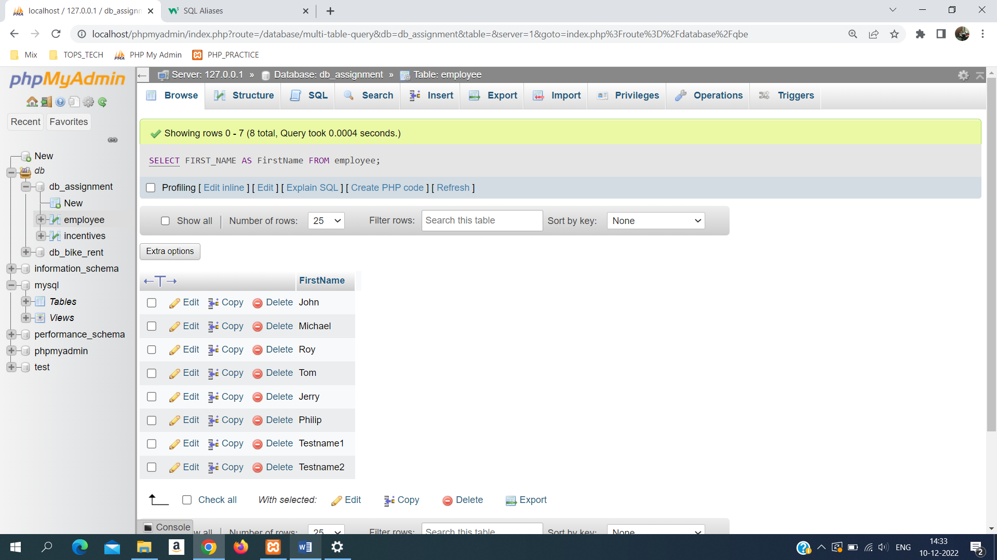

**b).** SELECT first_name,year(joining_dt) as Join_Year, month(joining_dt) as Joining_Month ,joining_dt as Joining_Date from employee;

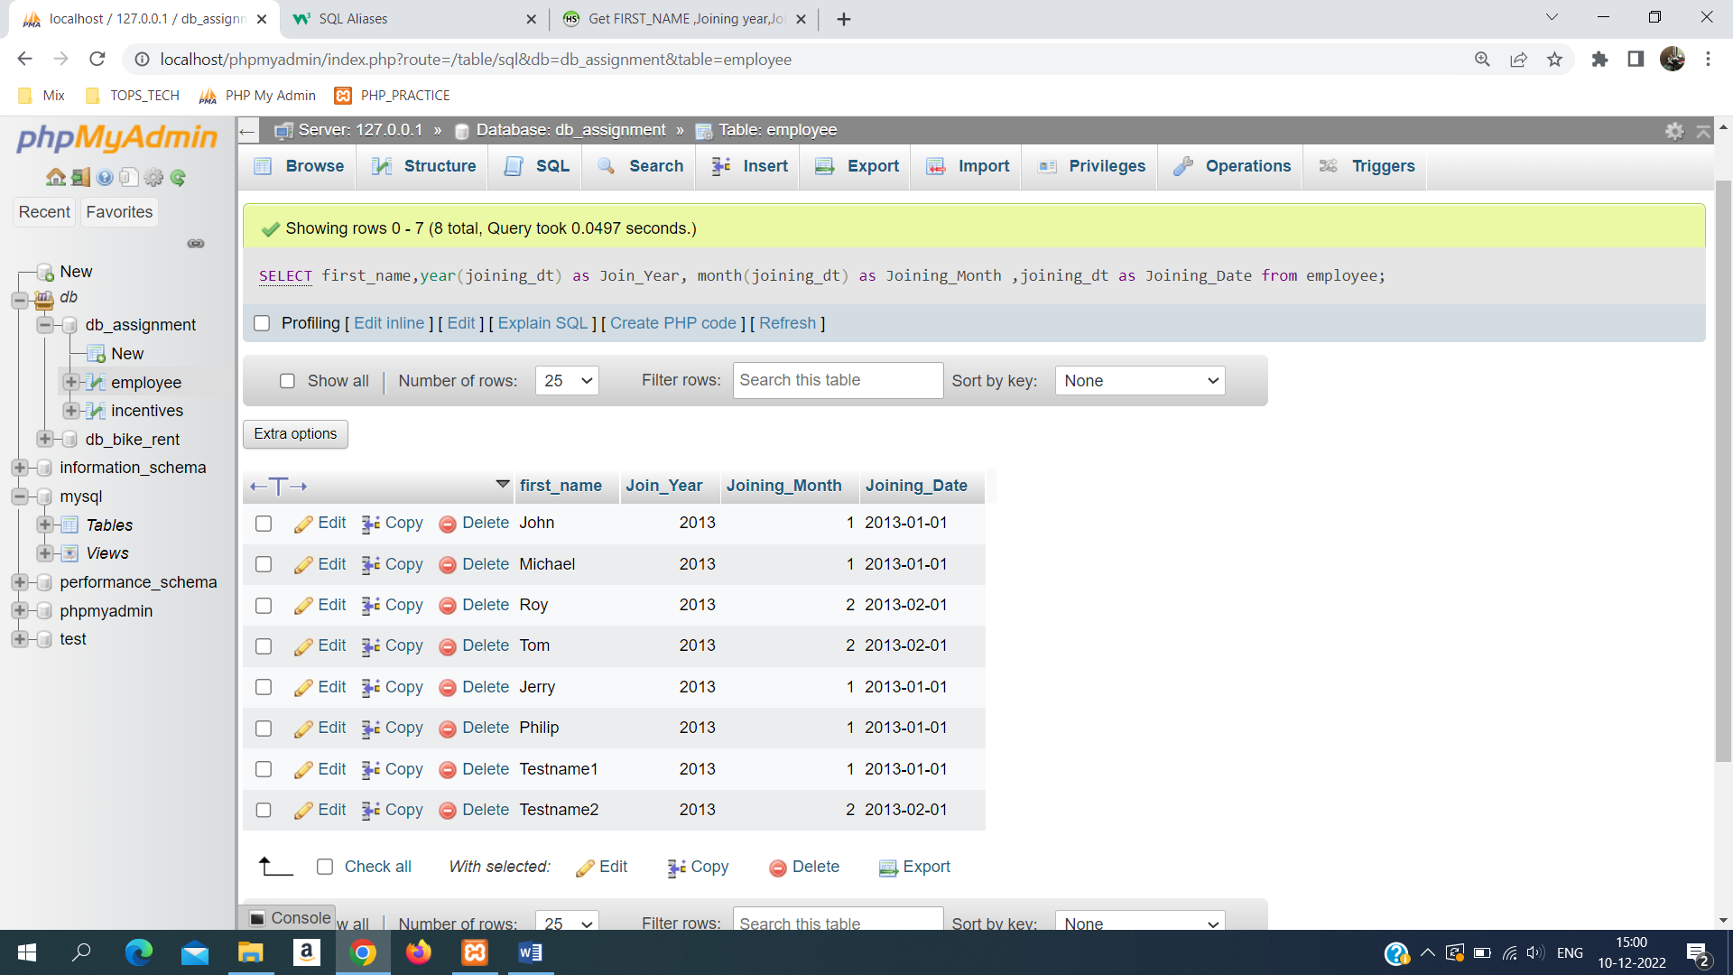

**c).** SELECT * FROM employee order by first_name ASC, salary DESC;

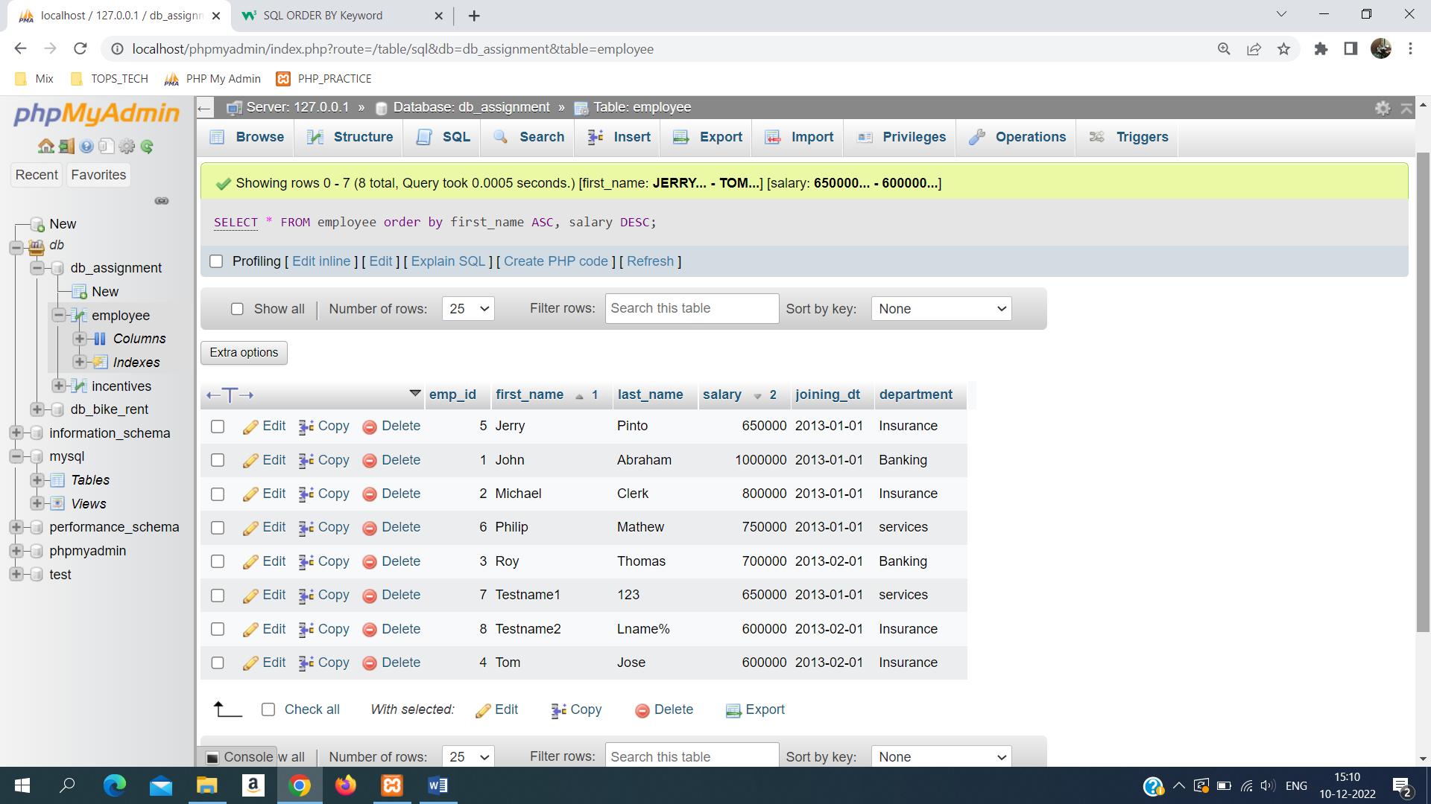

**d.)** SELECT * FROM employee where first_name LIKE '%o%';

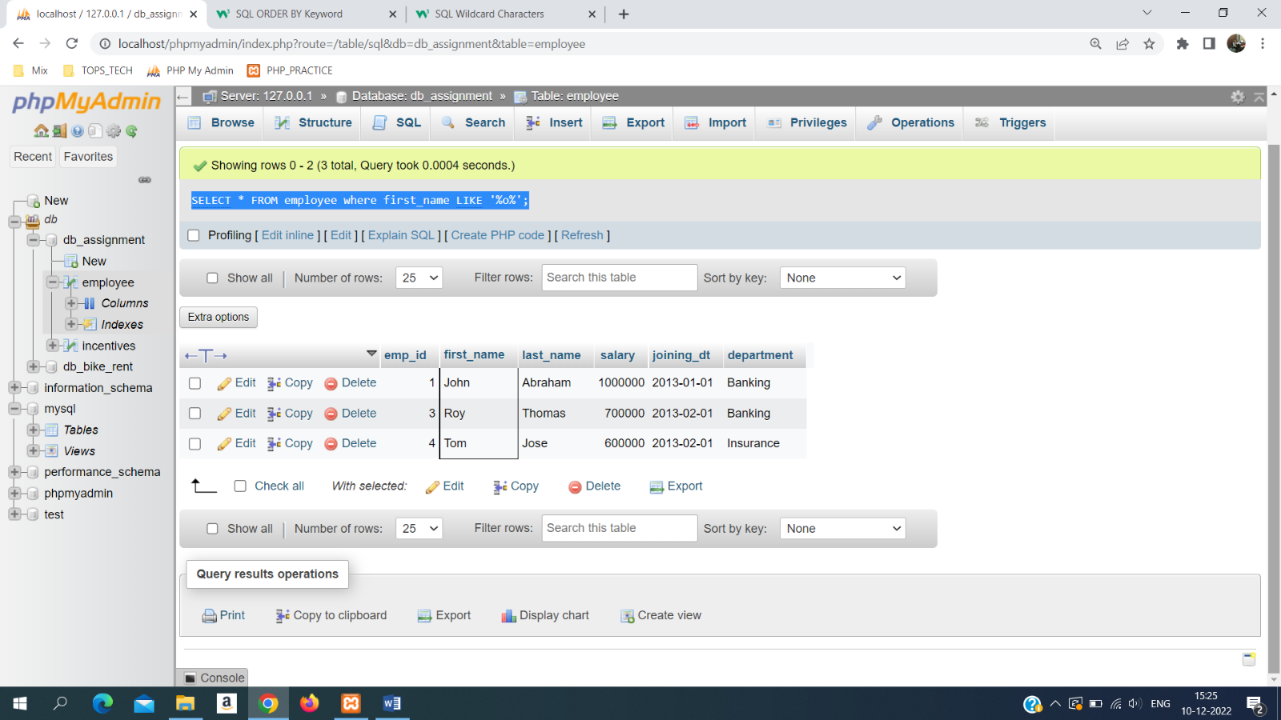

**e.)** SELECT * FROM employee where DATE_FORMAT(joining_dt,"%M")="January";

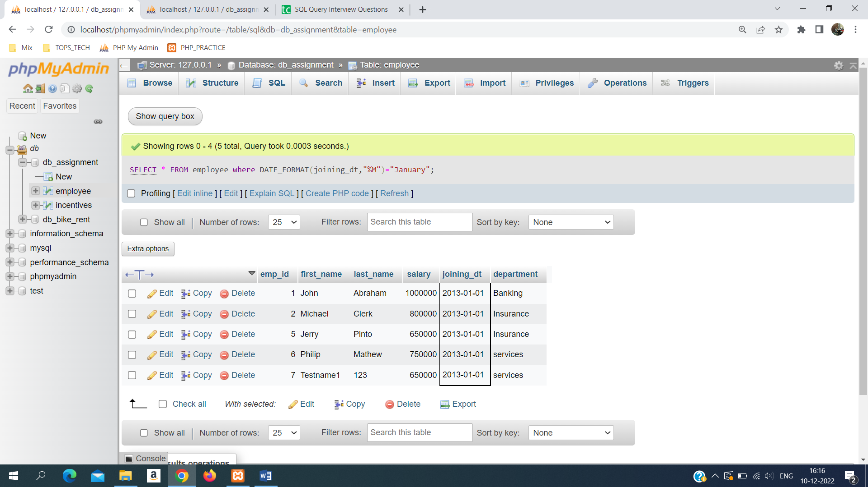

**f.)** SELECT department,SUM(salary) Total_Salary from employee GROUP by department ORDER BY Total_Salary ASC;

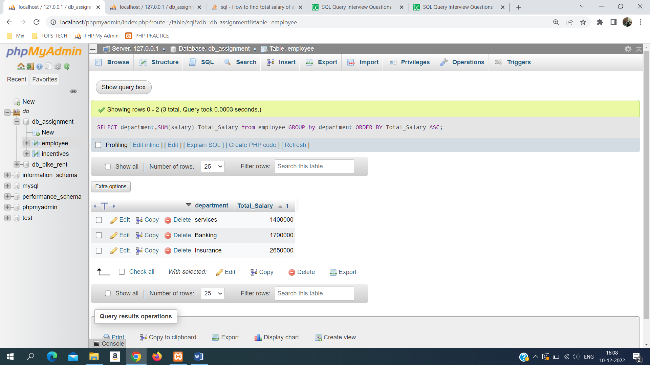

**g.)** SELECT department, max(salary) Max_Salary from employee GROUP BY department ORDER BY Max_Salary ASC;

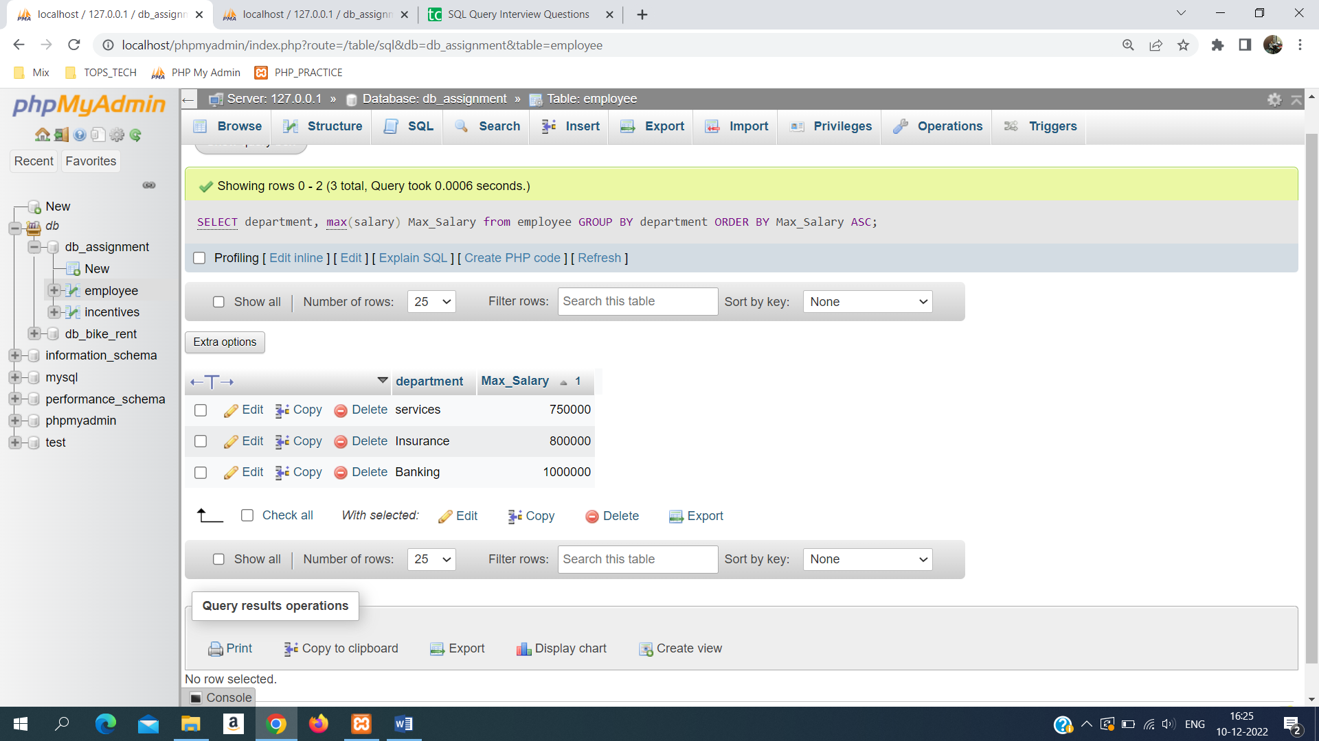

**h).** select first_name,incentive_amt from employee as a join incentives as i where a.emp_id = i.emp_ref_id and i.incentive_amt > 3000;

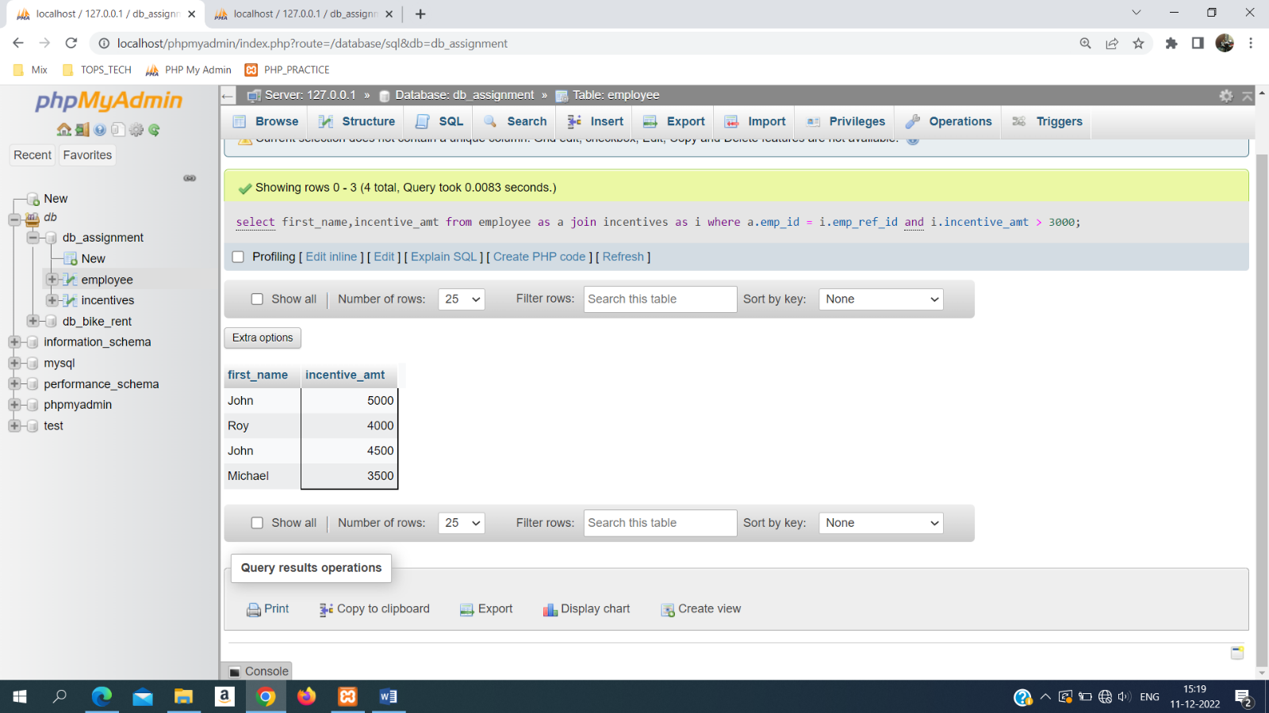

**i).** SELECT max(salary) from employee where salary < (select max(salary) from employee);

**OR**

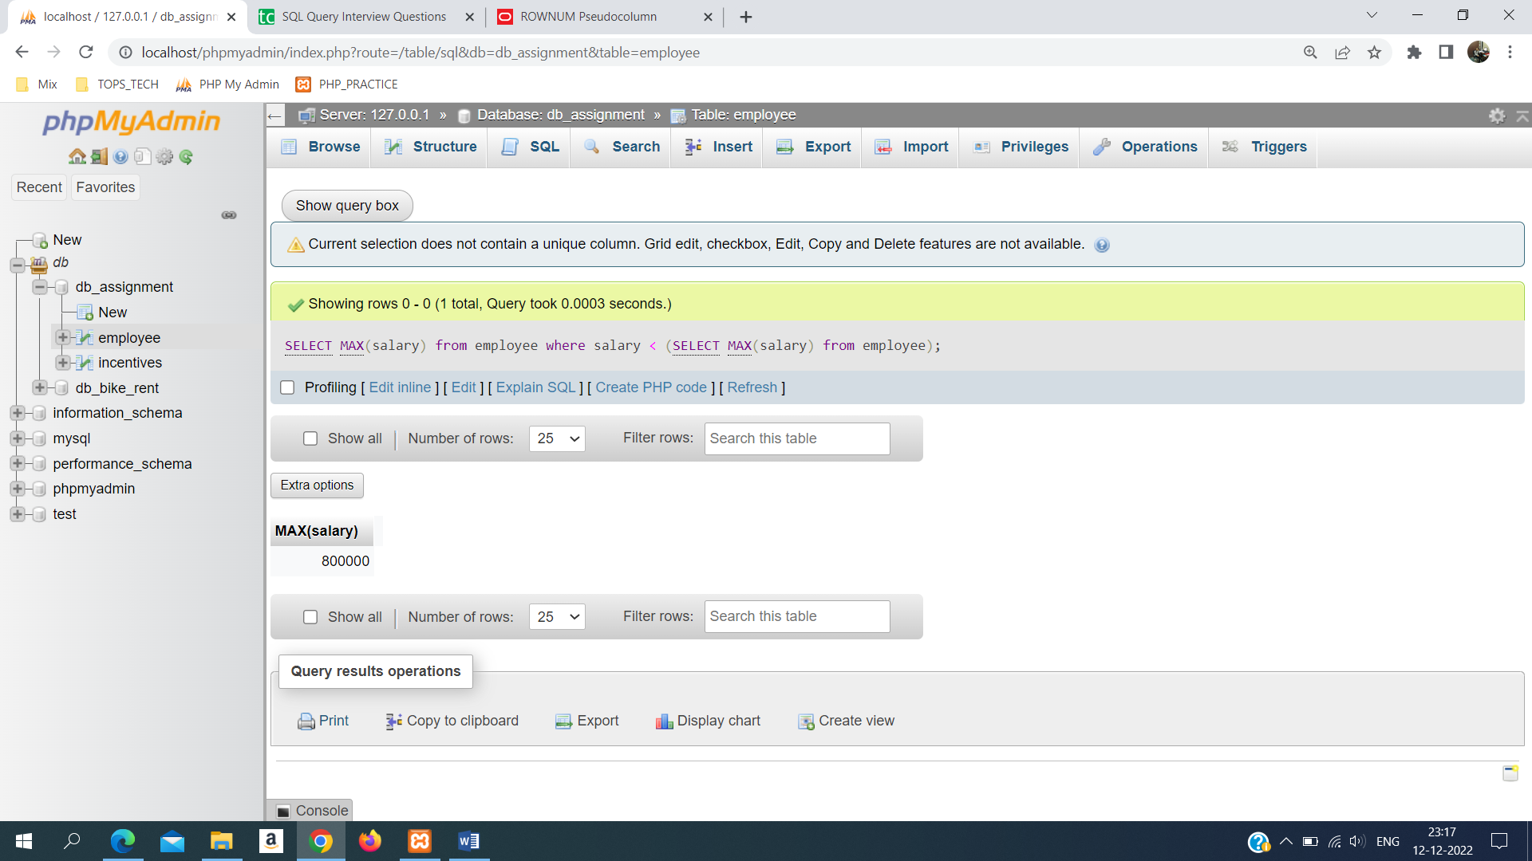

**j).** SELECT first_name,incentive_amt FROM employee e LEFT JOIN incentives i ON e.emp_id=i.emp_ref_id;

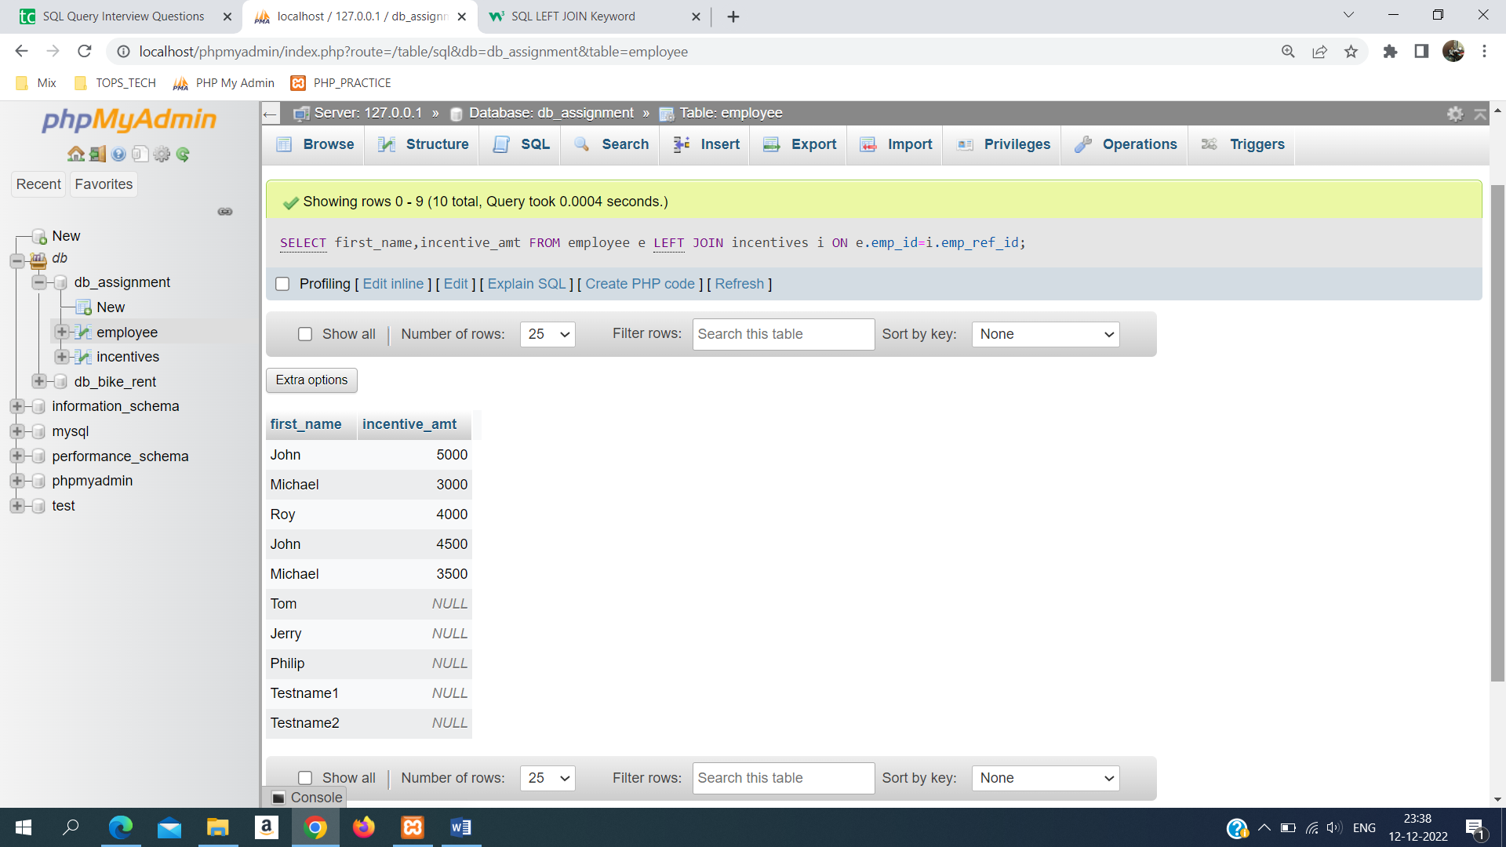

**k).** CREATE VIEW emp_incentives AS SELECT first_name,last_name,salary from employee;

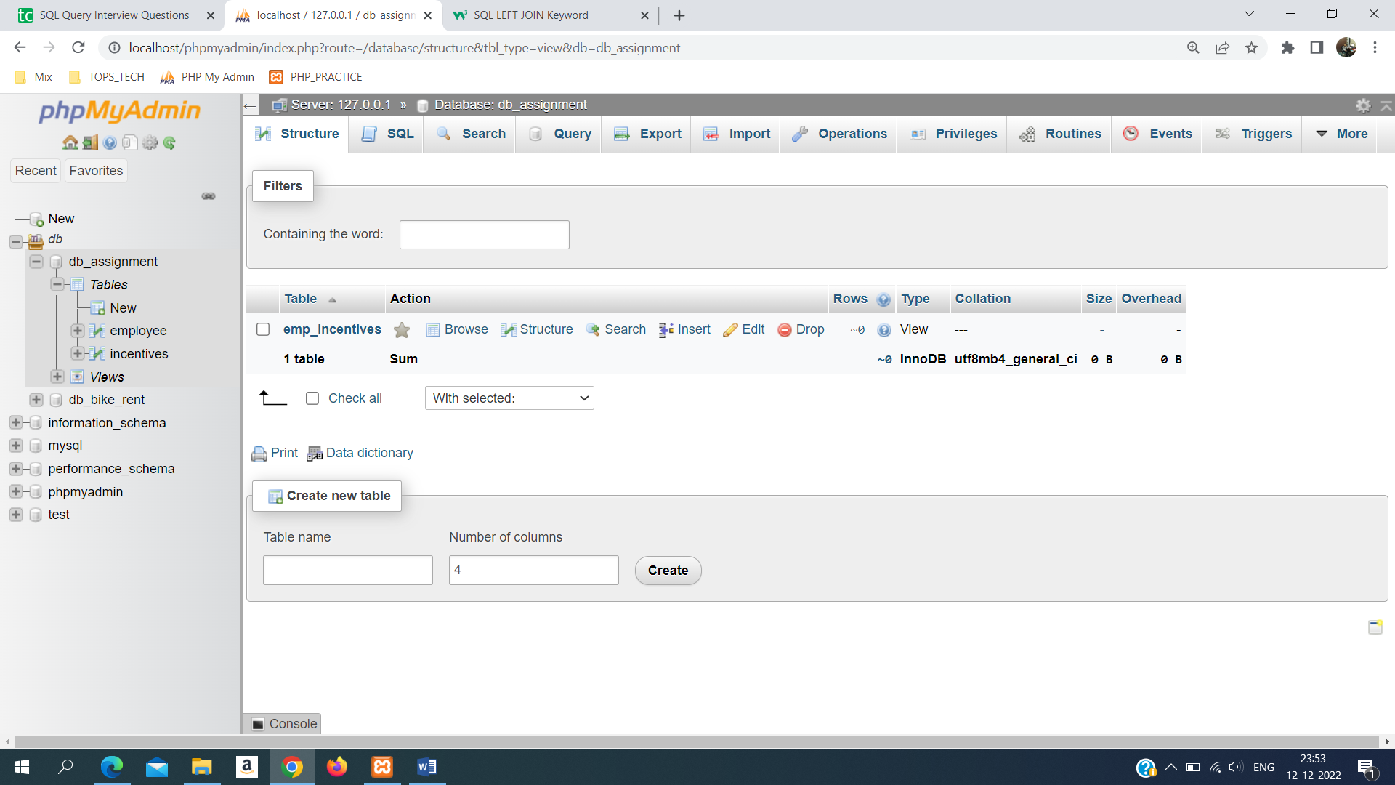

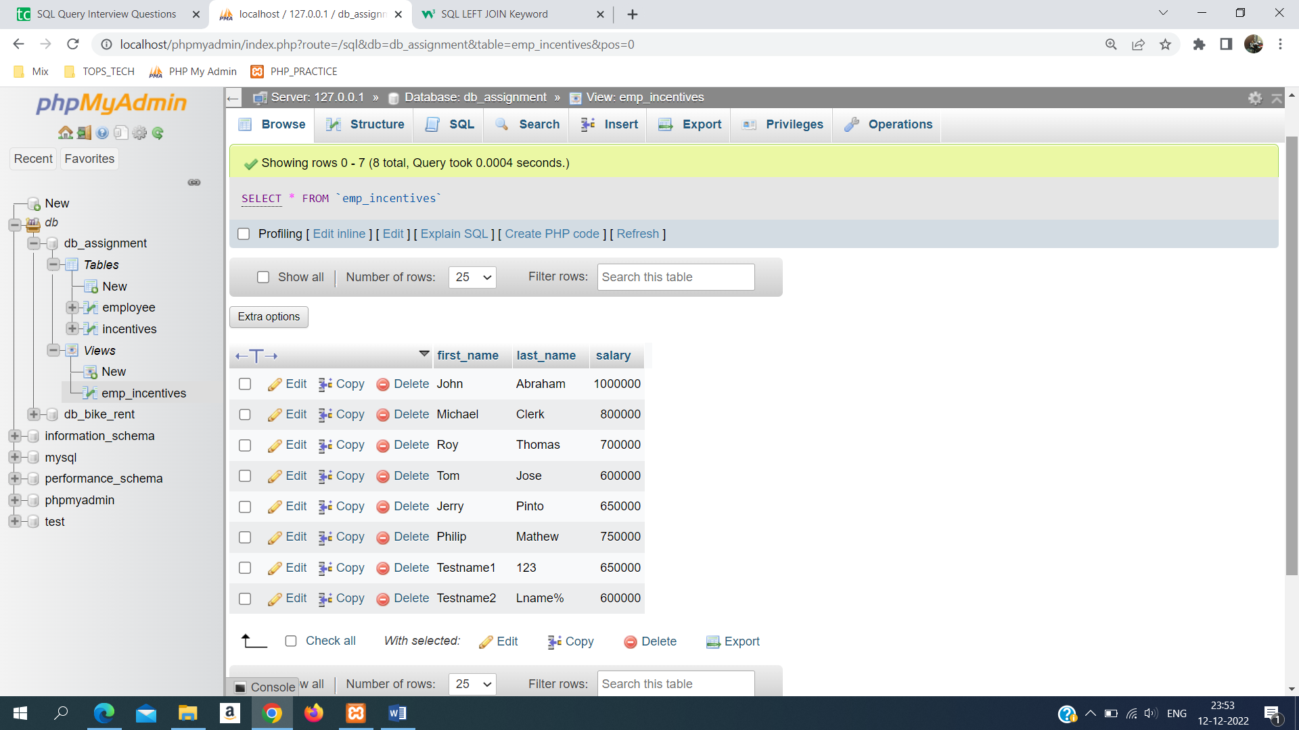

**l).**

CREATE PROCEDURE dept_wise_maxsal()

BEGIN

SELECT department, max(salary) from employee GROUP by department;

END//

call dept_wise_maxsal();

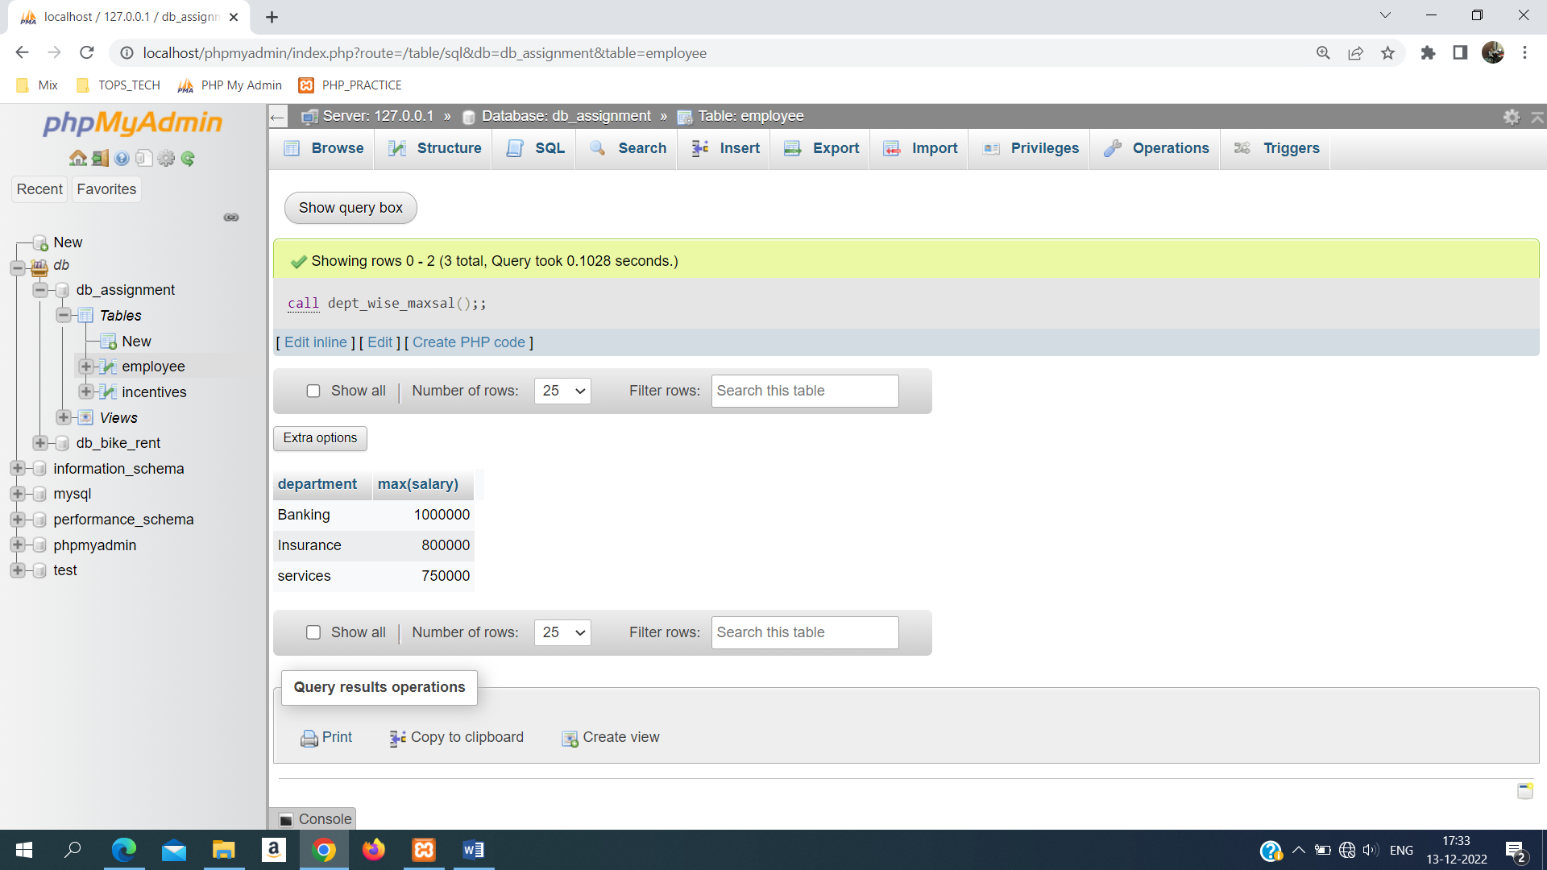

**Make a table reg_log**

create table reg_log(

reg_id int AUTO_INCREMENT,

emp_id int,

first_name varchar(255),

last_name varchar(255),

salary int,

joining_dt date,

department varchar(255),

modified_dt datetime,

constraint PK_reg_reg_id Primary KEY (reg_id)

);

**create TRIGGER insert_trigger_employee AFTER INSERT ON employee FOR EACH ROW**

**BEGIN**

**insert into reg_log(emp_id,first_name,last_name,salary,joining_dt,department,modified_dt) VALUES**

**(new.emp_id,new.first_name,new.last_name,new.salary,new.joining_dt,new.department,now());**

**END//**

**TASK-2**

create table sales_person(

sno int AUTO_INCREMENT,

sname varchar(255),

city varchar(255),

comm float,

CONSTRAINT PK_sales_person PRIMARY KEY (sno)

);

create table customer(

cid int AUTO_INCREMENT,

cname varchar(255),

city varchar(255),

rating int,

sno int,

CONSTRAINT PK_customer PRIMARY KEY (cid),

CONSTRAINT FK_customer_sno FOREIGN KEY (sno) REFERENCES sales_person(sno)

);

create table order_tbl(

onm int AUTO_INCREMENT,

amt float,

ode datetime,

cid int,

sno int,

CONSTRAINT PK_order_tbl PRIMARY KEY (onm),

CONSTRAINT FK_order_cid FOREIGN KEY (cid) REFERENCES customer(cid),

CONSTRAINT FK_order_sno FOREIGN KEY (sno) REFERENCES sales_person(sno)

);

**SQL ANSWERS**

**a).** **All orders for more than $1000.**

select * from order_tbl where amt > 1000;

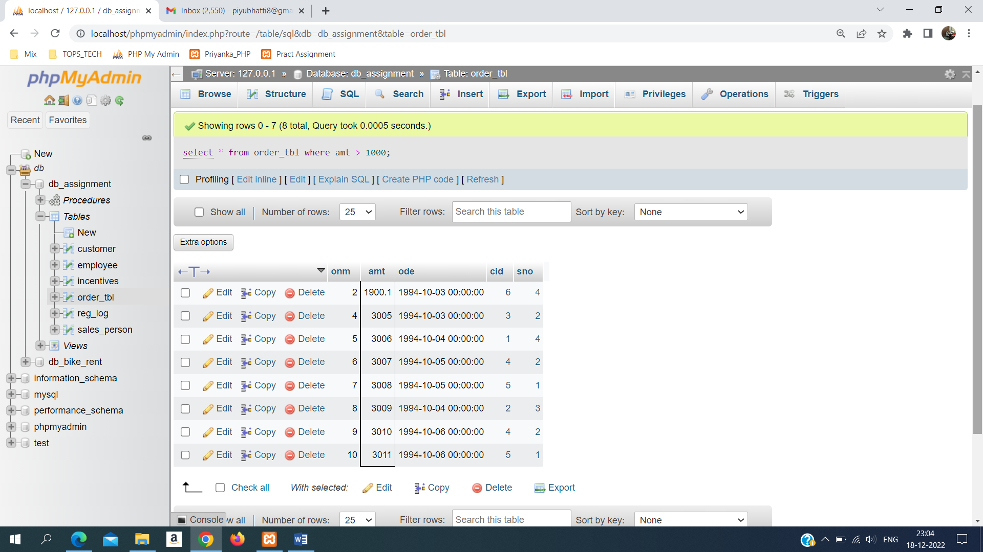

**b.) Names and cities of all salespeople in London with commission above 0.10.**

select sname,city from sales_person where comm > 0.10;

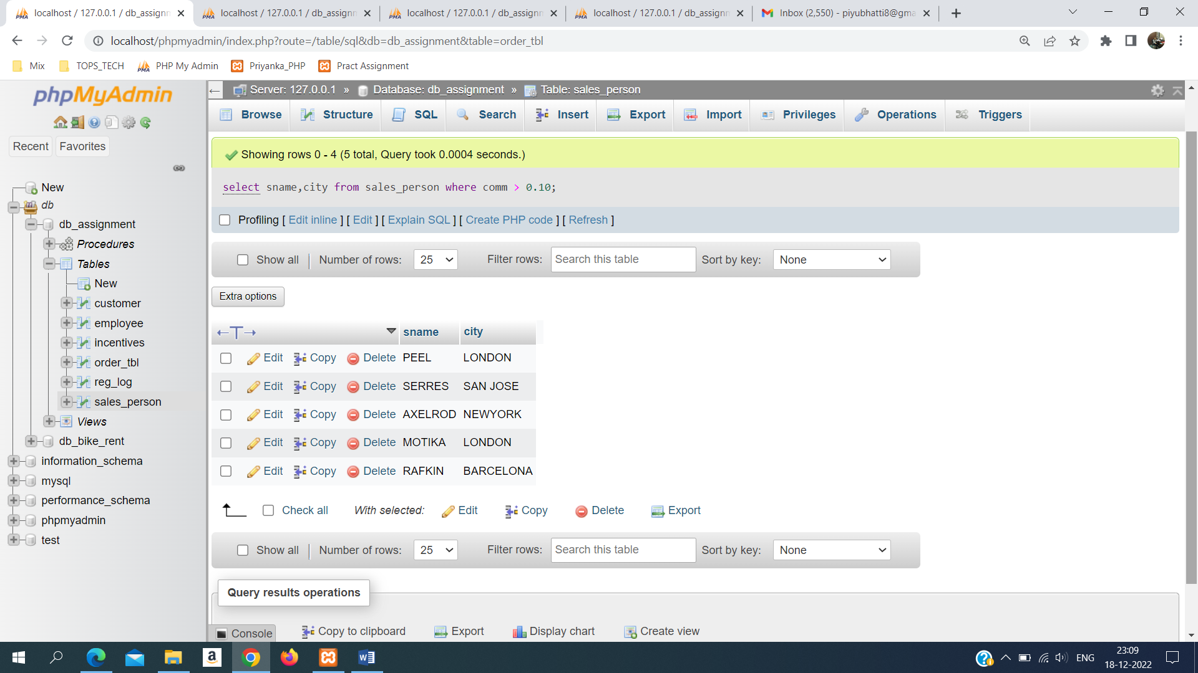

**c). All salespeople either in Barcelona or in London.**

SELECT * FROM sales_person WHERE city="BARCELONA" OR city="LONDON";

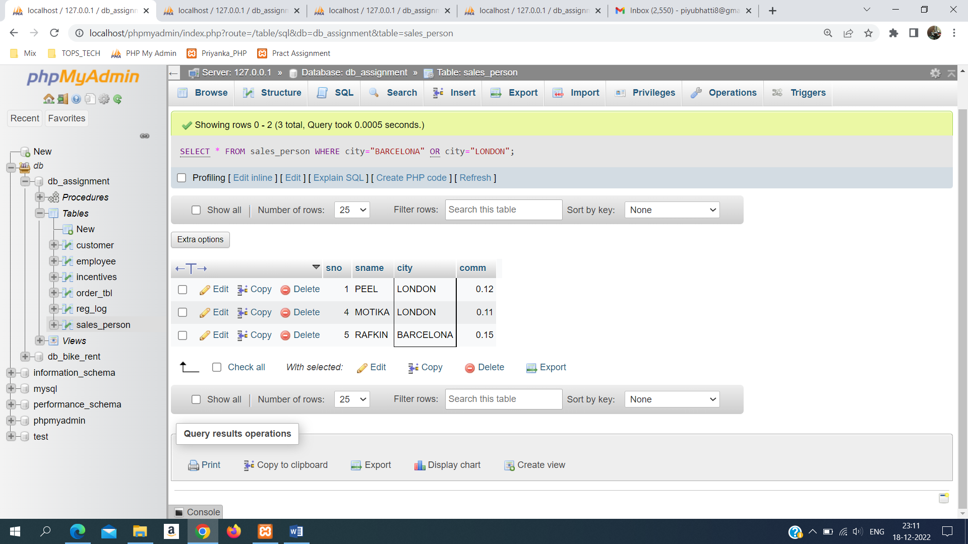

**d). All salespeople with commission between 0.10 and 0.12. (Boundary values should be excluded).**

SELECT * FROM sales_person WHERE (comm > 0.10 AND comm < 0.12);

**e). All customers with NULL values in city column.**

select * from customer WHERE city is NULL;

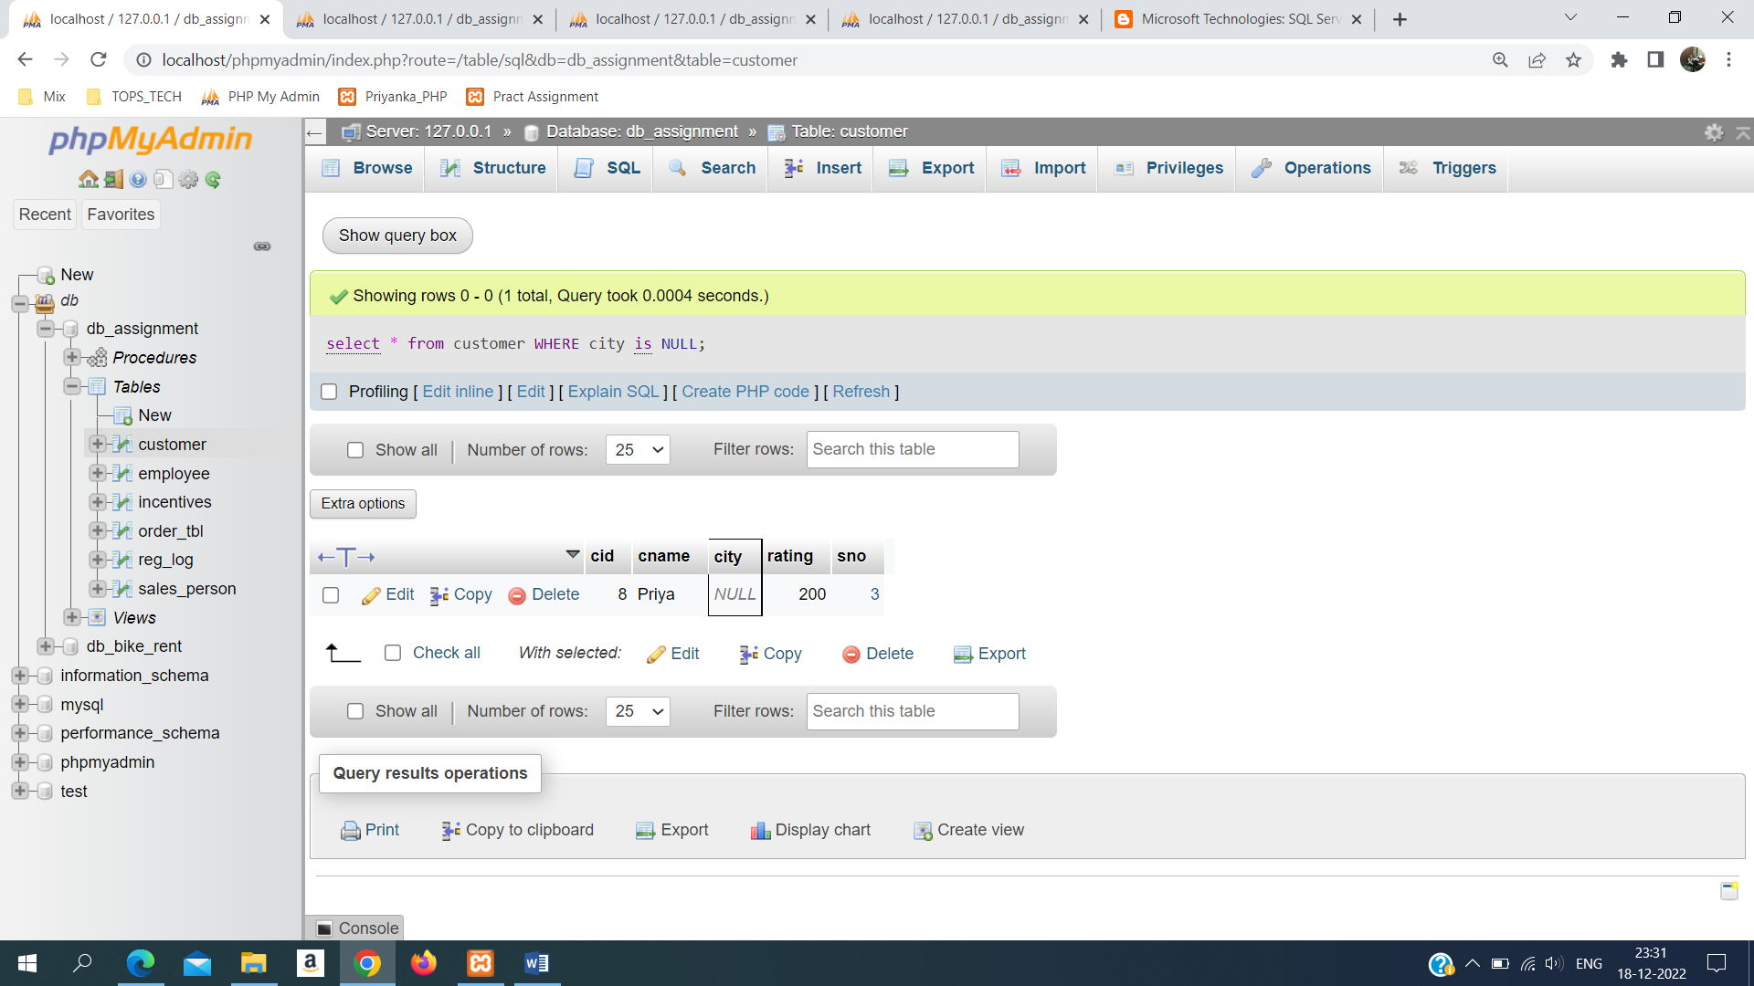

**f). All orders taken on Oct 3Rd and Oct 4th 1994.**

select * from order_tbl where ode IN('1994-10-03','1994-10-04');

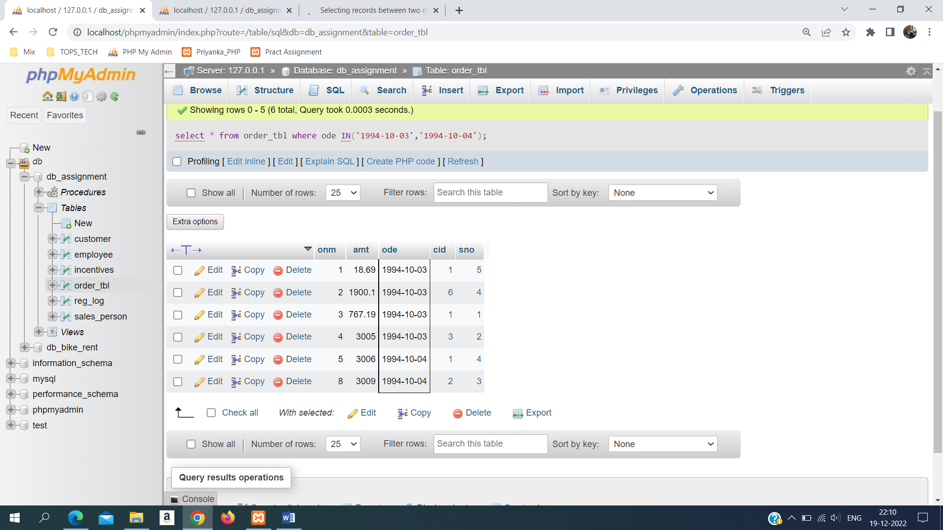

**g). All customers serviced by peel or Motika.**

SELECT DISTINCT c.cname, s.sname FROM customer as c,

order_tbl AS o,

sales_person AS s

WHERE o.cid=c.cid AND o.sno=s.sno AND sname IN ('PEEL','MOTIKA');

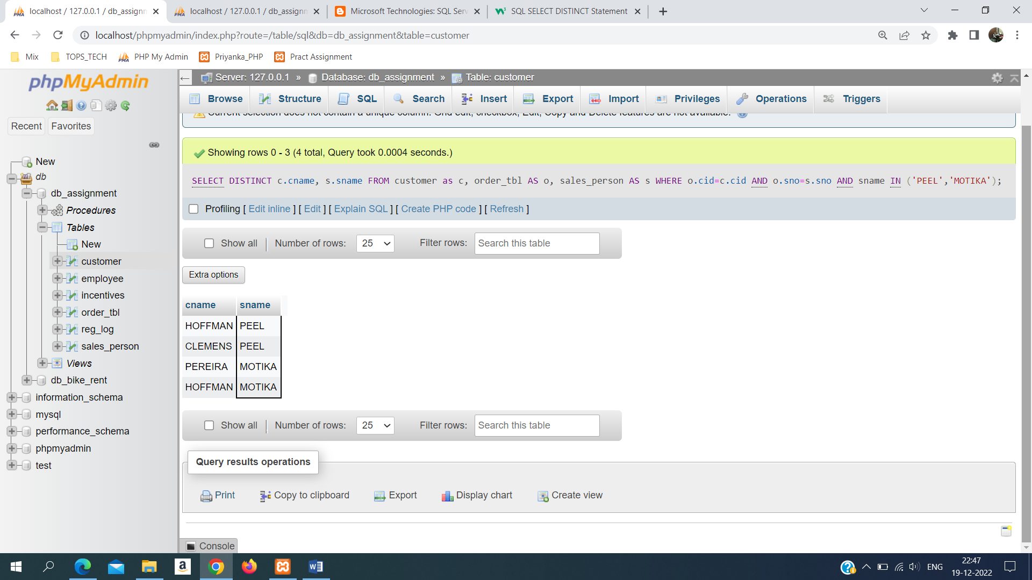

**h). All customers whose names begin with a letter from A to B**

SELECT * FROM customer WHERE cname LIKE 'A%' or cname LIKE 'B%';

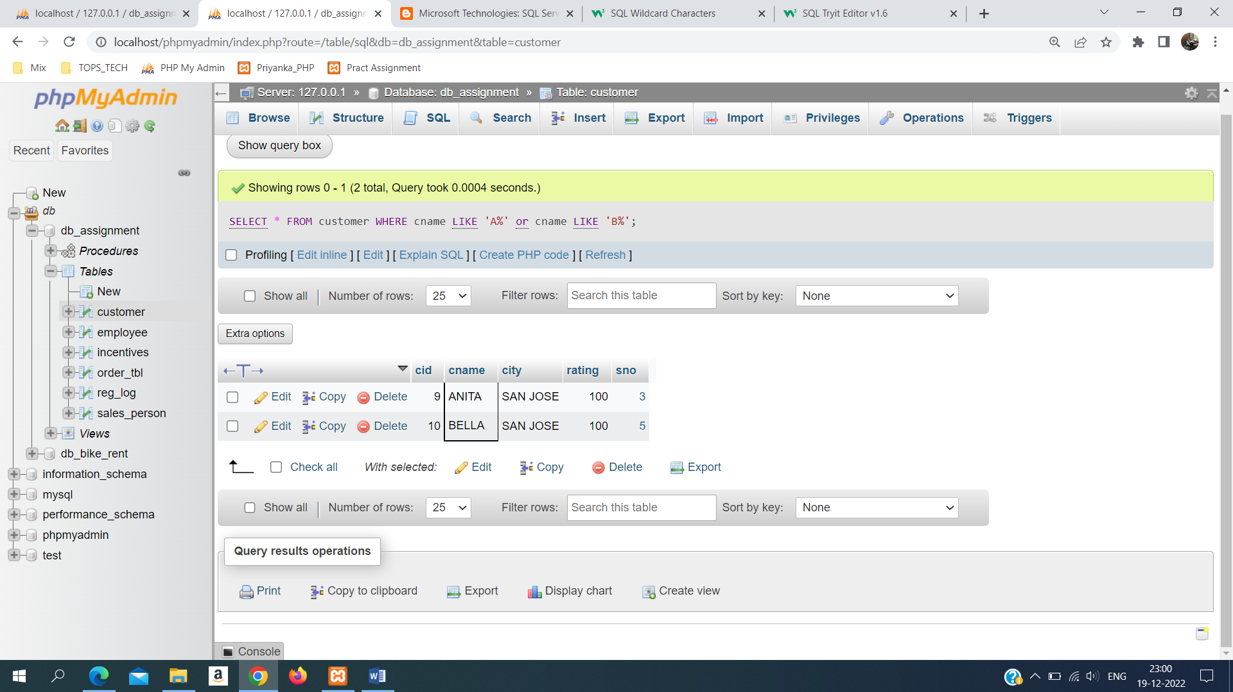

**i). All customers excluding those with rating <= 100 unless they are located in Rome.**

SELECT cname,city,rating from customer WHERE rating <=100 or city="ROME";

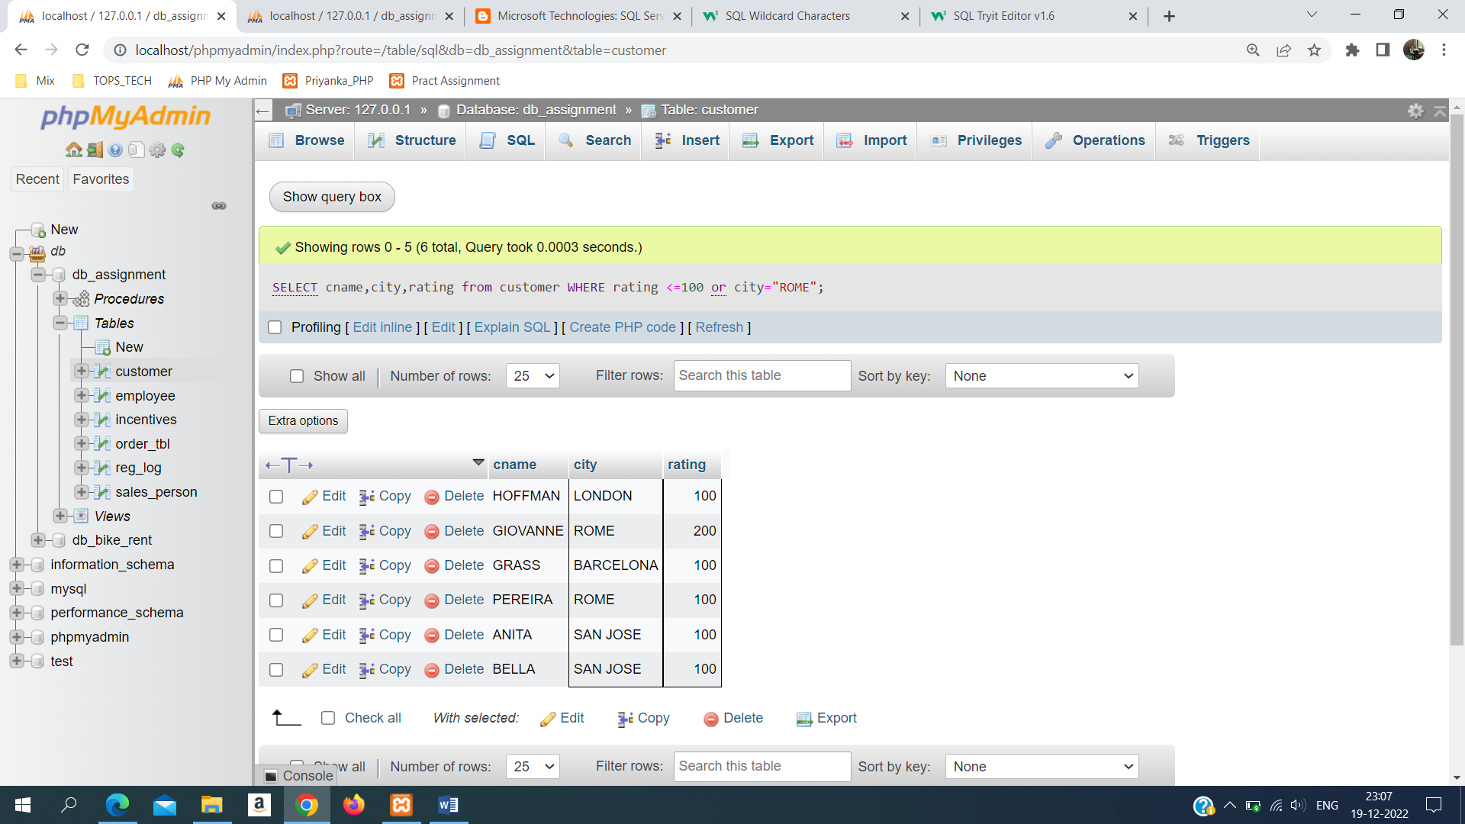

**j). All orders except those with 0 or NULL value in amt field.**

SELECT * FROM order_tbl WHERE amt IS NOT NULL OR amt <> 0;

**k). Count the number of salespeople currently listing orders in the order table.**

SELECT COUNT(DISTINCT sno) FROM order_tbl;

